FIGURES AND TABLES

FIGURE 1
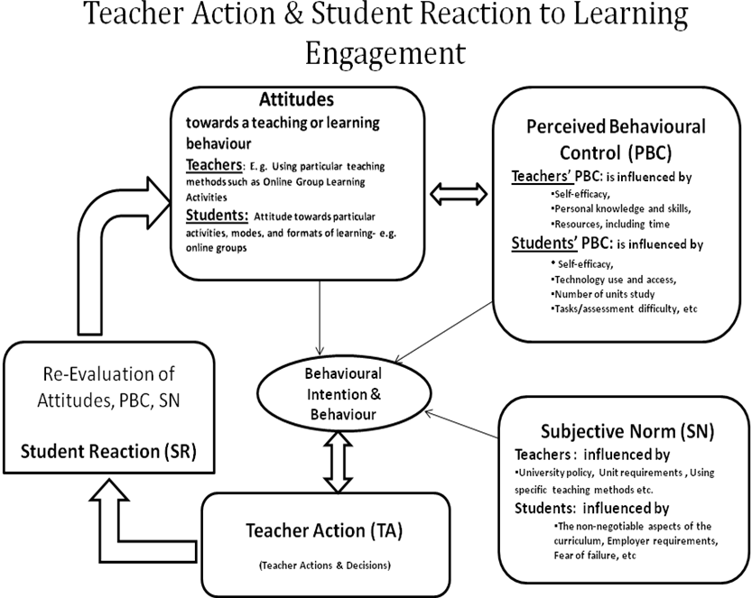
Figure1: The Model of Teacher Actions & Student Reaction to Teaching and Learning (Kuyini 2009)

Table 1
Table 1: Student perceptions about online group learning
Item | Not at all  (Number & Percentage) | Little  (Number & Percentage) | Much  (Number & Percentage) | Very Much  (Number & Percentage) | Total
I like online groups | 29 (19%) | 64 (43%) | 47 (32)% | 9 (6%) | 149 (100%)
Online group will give me a sense of control over my learning | 27(18 %) | 81 (54 %), | 36 (24 %) | 5(3 %) | 149 (100%)
Online group will help learning in Unit | 4 (3 %), | 38 (26%), | 69 (46 %) | 38 (26%). | 149 (100%)
Online group will help learning in deep way | 5 (3 %), | 52 (35%) | 68 (45%) | 24 (17%) | 149 (100%)

Table 2: Students responses on arrangements that facilitate participation in online groups

Item sub-sets | Item | Not at all No. ( % ) | Yes  No. ( % ) | Doesn’t Matter  No. ( % )
“Student Making a Choice”  (PERCEIVED BEHAVIOURAL CONTROL) | Choosing a group gives me a sense of control over my learning | 8 (5 %) | 33 (22 %) | 108 (72 %).
“Student Making a Choice”  (PERCEIVED BEHAVIOURAL CONTROL) | Being placed in a group gives me a sense of control over my learning | 35 (23 %) | 19 (13%) | 95 (64%).
“Task /Activity Flexibility”  (PERCEIVED BEHAVIOURAL CONTROL) | Making the online activities flexible gives me a sense of control over my learning | 7 (5%) | 114 (76 %) | 28 (19%)
 | Giving more than a week to respond to activity/tasks gives me a sense of control over my learning | 8 (5 %). | 109 (73 %) | 32 (22 %)
“Teacher Motivation Actions/Provisions”  ( SUBJECTIVE NORM ) | Equal participation is important and makes me more likely to meet unit demands | 3 (2%) | 109 (73 %) | 37(25 %)
“Teacher Motivation Actions/Provisions”  ( SUBJECTIVE NORM ) | Awarding scores for participation makes me more likely to meet unit demands | 11 (7 %) | 90 (60 %) | 48 (32 %)
“Teacher Motivation Actions/Provisions”  ( SUBJECTIVE NORM ) | Teacher availability makes me more likely to meet unit demands | 4 (3%) | 123 (82 %) | 22 (15%)

Table 3a
Table 3a: Students responses to the effects of participation in online group activities
Item | Remained negative | Remained positive | Changed to positive | Changed to negative
The unit’s activities changed my attitudes towards Online group work | 11 (19 %) | 24 (41%) | 13 (22%) | 10 (17 %)

Table 3b(2)
Paired Samples Statistics
 |  | Mean | N | Std. Deviation | Std. Error Mean
Pair 1 | Pre Course Attitude Towards Online groups | 1.60 | 58 | .493 | .065
Pair 1 | Post Course Attitude Towards Online Groups | 1.64 | 58 | .485 | .064

Table 3b

Table 3b: Students responses to the effects of participation in online group activities
Item | Not at all  Number & Percentage) | Little  Number & Percentage) | Much  Number & Percentage) | Very Much  Number & Percentage)
Online group gave me a sense of control over learning | 10 (17 %) | 32 (55%) | 14 (24%) | 2 (3%)
Online groups helped my learning in Unit, | 6 (10%) | 27 (47%) | 15 (26 %) | 10 (17%)
Online groups helped my learning in a deep way | 13 (22%) | 22 (38 %) | 16 (28%) | 7 (12%)
Teacher availability and support contributed to my participation | 11 (19 %) | 16 (27.5%) | 19 (33%) | 12 (21%)
Flexibility of online group activities contributed to my participation | 6 (10 %) | 22 (38%) | 21 (36%) | 9 (16%)
The award of scores for participation contributed to my participation | 15 (26 %) | 17 (29%) | 12 (21 %) | 14 (24%)
*Making a choice of groups was not measured because the initial survey found that is was not important

Paired Samples Test
 |  | Paired Differences |  |  |  |  | t | df | Sig. (2-tailed)
 |  | Mean | Std. Deviation | Std. Error Mean | 95% Confidence Interval of the Difference |  | t | df | Sig. (2-tailed)
 |  |  |  |  | Lower | Upper | t | df | Sig. (2-tailed)
Pair 1 | Pre Course Attitude Towards Online groups - Post Course Attitude Towards Online Groups | -.034 | .620 | .081 | -.198 | .129 | -.423 | 57 | .674

